JOHNNY THUNDERS
‘Que Sera Sera – Resurrected’ 3xCD Box Set

- The 1985 studio album – remixed and revamped with many unheard tracks
- Remixed by The Vibrators’ Pat Collier, finding two new tracks plus six bonus outtakes.
- Bonus live Disc 2 ‘Que Sera Sera – live in Europe’ has 18 tracks selected from three gigs
- Disc 3 is the original album and related single tracks in their original form
- Plus a 36-page booklet featuring new notes by Nina Antonia, lyrics and unseen photos
- LISTEN: Preview the ‘I Only Wrote’ digital single: https://promo.theorchard.com/OfEWegskg3Vrdg4FZxzp

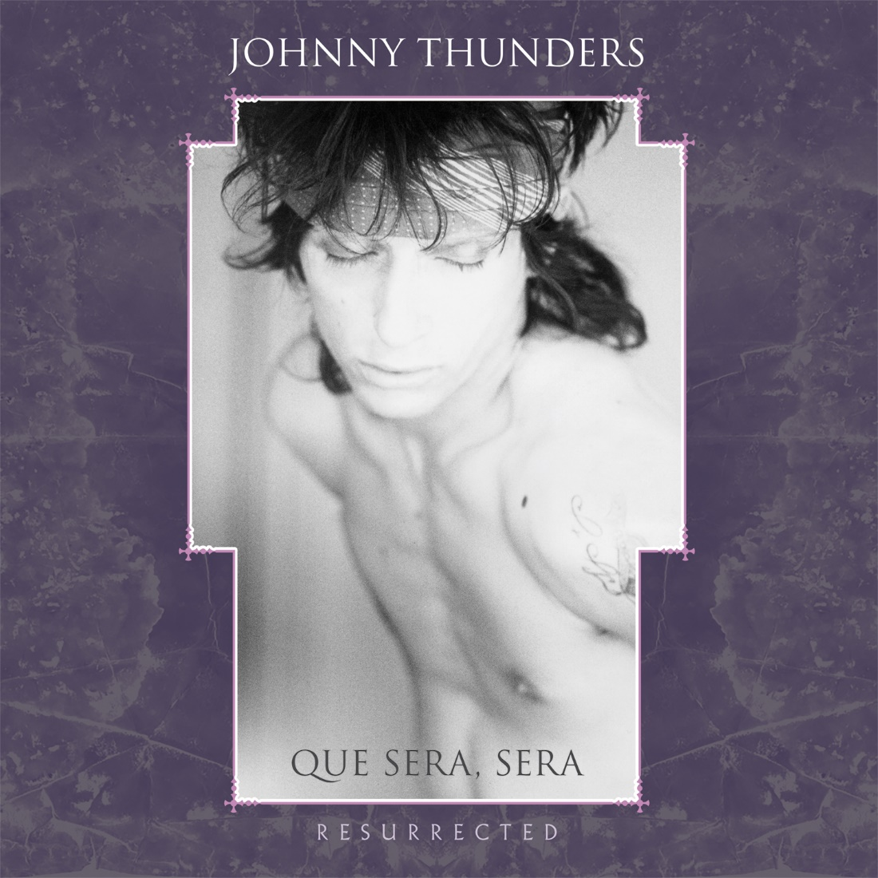

35th anniversary remake edition of the 1985 studio album. Features Mike Monroe, John Perry, Patti Palladin, Wilko Johnson, Stiv Bators, Glen Matlock and others. Disc 1: Remixed by The Vibrators' Pat Collier, with the guitar fully in the mix – Johnny missed the original mixing sessions. Expanded with two unreleased tracks left off the original album, plus six previously unheard outtakes. Disc 2 has eighteen mostly unheard live tracks from Amsterdam, Lyon & Geneva. Disc 3 is the original album and single mixes. New notes in a 36-page booklet by Thunders biographer Nina Antonia with interviews with Mike Monroe and others, plus lyrics and unseen photos. Packaged in a clam-shell box.

DISC 1: Resurrected: Alone In A Crowd, Countdown Love, Blame It On Mom, Talk About You, M.I.A., Little Bit Of Whore, Short Lives, I Only Wrote This Song For You, Cool Operator, Billy Boy, Endless Party, Que Sera Sera. Extras: Copy Cat, Blame It On Mom (outtake),Taking You Up Avenue D, Short Lives (outtake), I Only Wrote This Song For You (outtake), Cool Operator (first version).
DISC 2: Live in Europe: Geneva: Blame It On Mom, M.I.A., Cool Operator, Personality Crisis, Countdown Love, Little Bit of Whore, Amsterdam: Short Lives, So Alone, Sad Vacation, Too Much Junkie Business, Little Bit of Whore, Born To Lose, Chinese Rocks, Lyon: Countdown Love, Just Another Girl, Talk About You, Alone In A Crowd, It’s Alright (Blame It On Mom). (74 mins)
DISC 3: The original album: Short Lives, M.I.A., I Only Wrote This Song For You, Little Bit of Whore, Cool Operator, Blame It On Mom, Tie Me Up, Alone In A Crowd, Billy Boy, Endless Party, Cool Operator (Black Cat mix), Short Lives (Heavenly ver.), Short Lives (Johnny’s remix), Que Sera Sera

FREUDCD129 (3xCD Box Set) UKDP: £11.99 5013145212929
Still available - a limited quantity of left-over RSD2019 coloured vinyl 2xLPs:
FREUDLP129 (2xLP col vinyl) UKDP: £11.99 5013145212936

RELEASE DATE: SEPT 11 2020. Territory restriction: NORTH AMERICAN DISTRIBUTION: MVD

File under: Punk Rock; Johnny Thunders; NY Punk.
JUNGLE RECORDS SUITE B2 LIVINGSTONE COURT 55 PEEL ROAD WEALDSTONE HARROW HA3 7QT
Tel +44(0)20 8537 3444 e:enquiries@jungle-records.com

