www.thetubes.com
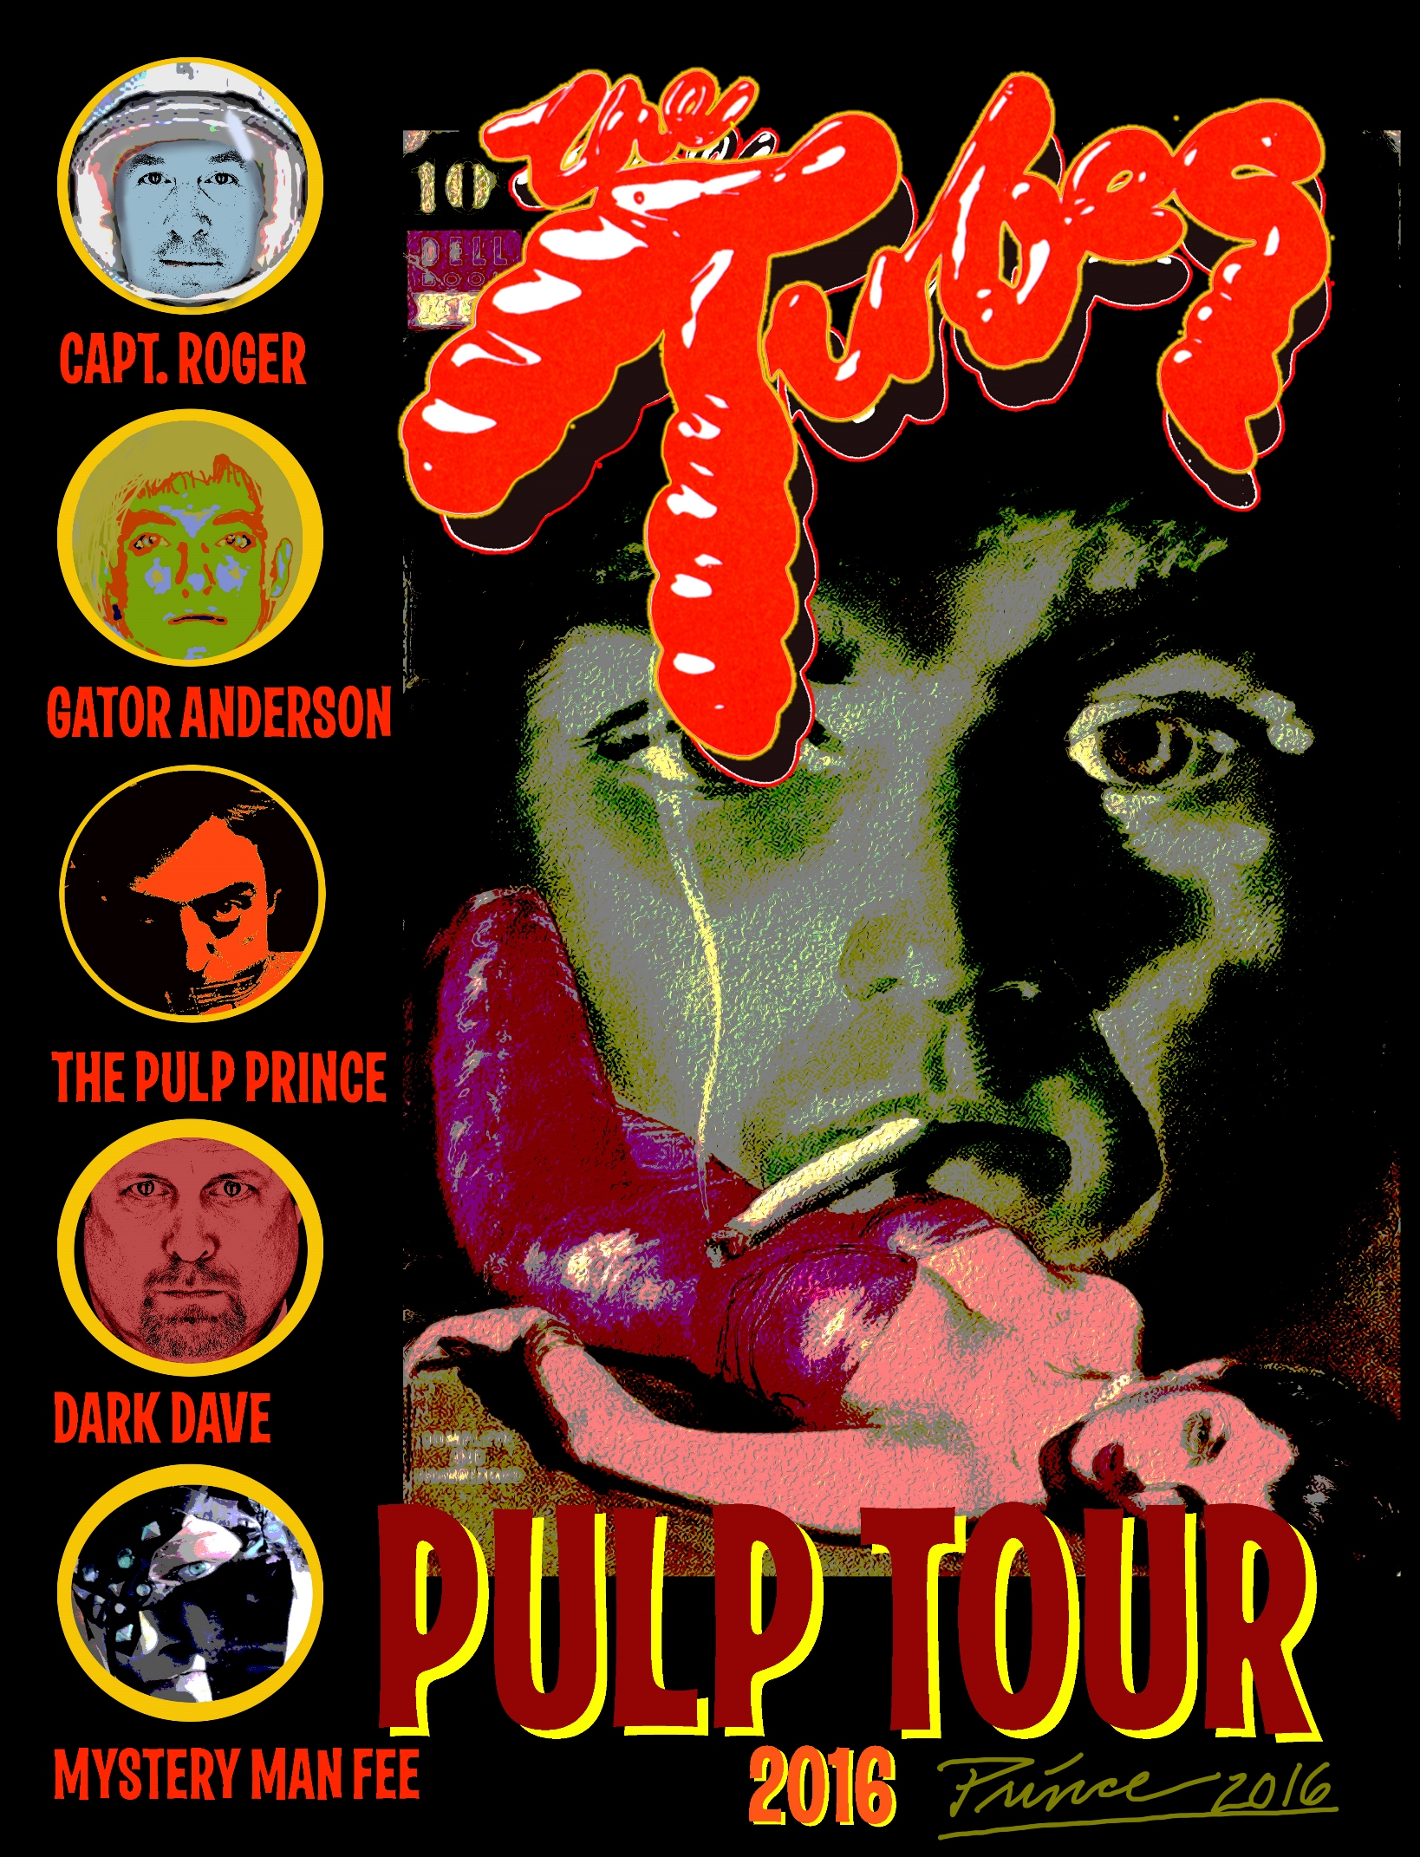
THE TUBES
MONDO PULP UK TOUR 2016

The Tubes, the San Francisco-based rock band, whose eponymous 1975 debut album included the unforgettable rock anthem "White Punks on Dope,” celebrates their return to the UK with their “MONDO PULP TOUR” - 12 nights of non-stop mayhem in the UK in October 2016.
“We’re thrilled to be coming back to the country that started it all for us,” says the Tubes frontman Fee Waybill. “I embrace my British heritage; the beer and the fish and chips and the best rock and roll fans in the world. The all-new Mondo Pulp Tour will be big fun!”
Founding member and drummer, Prairie Prince, who is also a well-respected graphic designer in his own right, has created a stunning tour poster to break in the Mondo Pulp 2016 Tour.
The festivities kick off at London’s Under the Bridge (Oct 7), followed by Manchester Academy (October 8), The Great British Alternative Music Festival, Skegness (Oct 9), Bristol Fleece (Oct 11), Plymouth the Hub (Oct 12), Cardiff Globe (Oct 14), Brighton Concorde 2 (Oct 15), Southampton Brook (Oct 16), Wolverhampton Robin 2 (Oct 18), Sage Gateshead (Oct 20), Holmfirth Picturedrome (Oct 21), and Glasgow Art School (Oct 22).
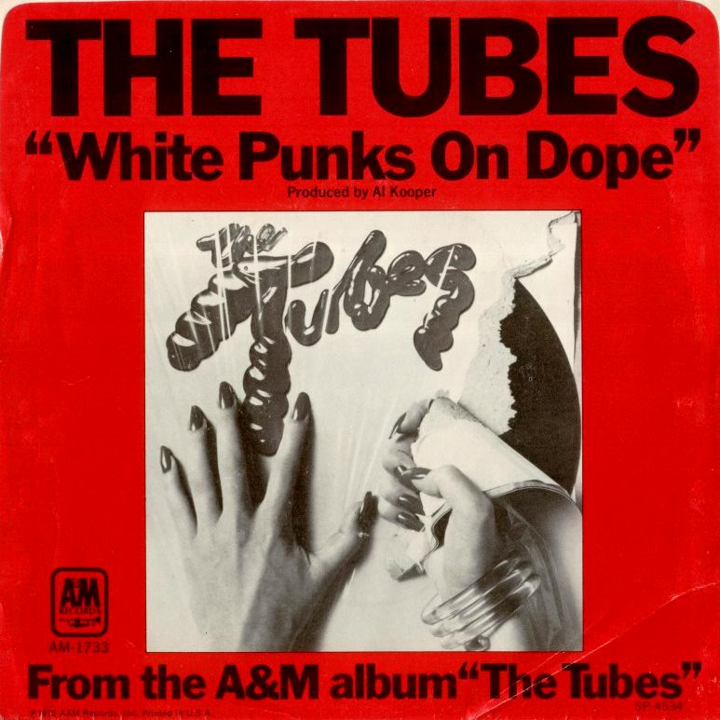
The band's over-the-top theatrical visual live performances are known to rock fans worldwide for their quasi-pornographic and satiric take on the media, consumerism, and politics, celebrated by lead singer Fee Waybill’s deranged on-stage characters, including the larger-than-life fictitious platform-booted, drugged out British glam rock star Quay Lewd.
In 1977 The Tubes toured the UK, but many of their shows were banned due to British censorship. In February 1978 they released the ground-breaking live album What Do You Want From Live - recorded at London’s Hammersmith Apollo in November 1977, followed by their UK television debut on The Old Grey Whistle Test.
The Tubes are best remembered for their 1983 single She's a Beauty, a top 3 U.S. hit single bolstered by a frequently-played music video in the early days of MTV.
The current line-up of The Tubes features four original members - Fee Waybill (lead vocals), Roger Steen (guitar), Rick Anderson (bass) and Prairie Prince (drums), plus David Medd (keyboards), the latter has played with the band since 2006.
The Mondo Pulp tour is a fantastic tribute to the Pulp Art era. The material will be different but the band promise to perform all the hits and fan favourites - What Do You Want From Life?, Mondo Bondage, Amnesia, Sushi Girl, Don’t Wanna Wait Anymore, Talk To Ya Later, She’s A Beauty and White Punks On Dope.
There’s even talk of a potential DVD release of a live show from German television dating back to 1982. There’s even talk about a possible live CD from the Tubes’ 2015 German tour.

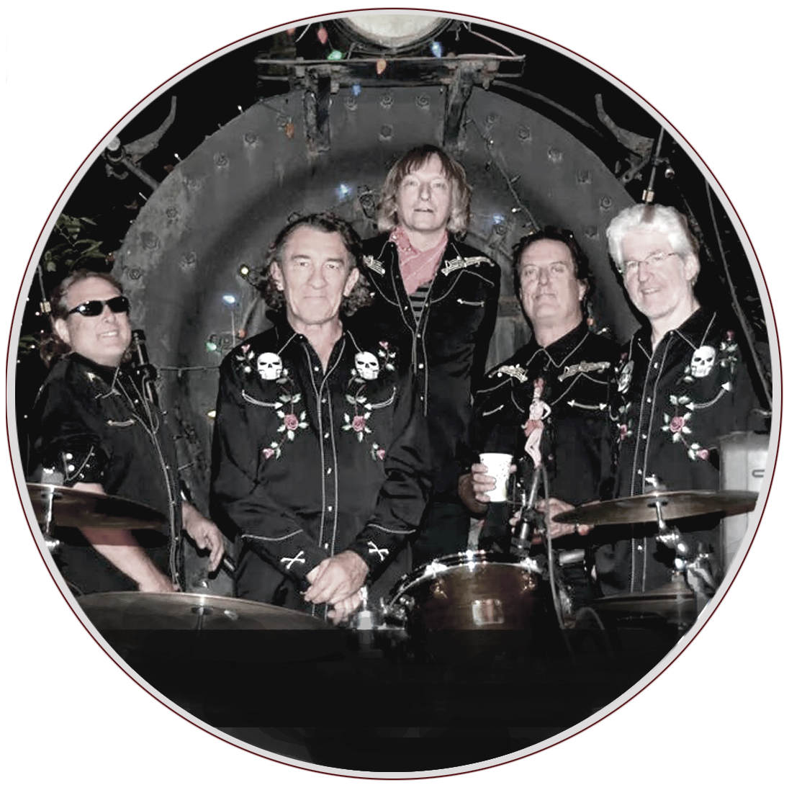

THE TUBES
MONDO PULP 2016 UK TOUR

LONDON, UNDER THE BRIDGE
FRIDAY 7 OCTOBER
TICKETS: £28.50 (INC. BOOKING FEE)
BOX OFFICE: 0207 957 8261
BOOK ONLINE: UNDER THE BRIDGE
EMAIL: info@underthebridge.co.uk
STAMFORD BRIDGE, FULHAM ROAD, LONDON, SW6 1HS
http://underthebridge.co.uk/
MANCHESTER CLUB ACADEMY
SATURDAY 8 OCTOBER
TICKETS: £27.50 (INC. BOOKING FEE)
BOX OFFICE: 0161 832 1111 / BOOK ONLINE AT AGMP
VENUE: FACEBOOK, TWITTER
DOORS: 19:30 / OXFORD ROAD, MANCHESTER, M13 9PR
www.manchesteracademy.net
THE GREAT BRITISH ALTERNATIVE MUSIC FESTIVAL, SKEGNESS
SUNDAY 9 OCTOBER
3-DAY WEEKEND TICKETS FROM £99
THE STRANGLERS, THE TUBES, FROM THE JAM, THE BLOCKHEADS, SPEAR OF DESTINY
BOX OFFICE: 0330 102 5295 / BOOK ONLINE: BIGWEEEKENDS / FACEBOOK
BUTLIN’S RESORT, SKEGNESS, LINCOLNSHIRE, PE25 1NJ
BigWeekends.Com
BRISTOL THE FLEECE
TUESDAY 11 OCTOBER
TICKETS: £27.50 (INC. BOOKING FEE)
BOX OFFICE: 0117 945 0996 (VENUE), 0370 44 44 400 or 0117 929 9008
BOOK ONLINE: THE FLEECE, SEE TICKETS, BRISTOL TICKET SHOP
VENUE: FACEBOOK, TWITTER / EMAIL: info@thefleece.co.uk
DOORS: 19:30 / 12 THOMAS STREET, BRISTOL, BS1 6JJ
http://thefleece.co.uk
PLYMOUTH THE HUB
WEDNESDAY 12 OCTOBER
TICKETS: £27.50 (INC. BOOKING FEE)
BOOK ONLINE: ENTS24 / BOX OFFICE: 0844 412 4642
VENUE: 07538 797 648
9 BATH STREET, PLYMOUTH, DEVON, PL1 2LT
THE HUB: OFFICIAL FACEBOOK
CARDIFF THE GLOBE
FRIDAY 14 OCTOBER
TICKETS: £27.50 (INC. BOOKING FEE)
BOX OFFICE: 0871 220 0260 / BOOK ONLINE: SEE TICKETS
VENUE TEL: 07590 471 888 / EMAIL: enquiries@themjrgroup.com
VENUE: FACEBOOK, TWITTER
125 ALBANY ROAD, CARDIFF, SOUTH GLAMORGAN, CF24 3NS
THE GLOBE: OFFICIAL WEBSITE
BRIGHTON CONCORDE 2
SATURDAY 15 OCTOBER
TICKETS: £26.50 (+ BOOKING FEE)
BOX OFFICE: 01273 673 311 / BOOK ONLINE: Concorde2
VENUE TEL: 01273 673 311 / VENUE EMAIL: hello@concorde2.co.uk
VENUE: FACEBOOK, TWITTER
MADEIRA DRIVE, BRIGHTON, EAST SUSSEX, BN2 1EN
www.concorde2.co.uk
SOUTHAMPTON THE BROOK
SUNDAY 16 OCTOBER
TICKETS: £24.20 (INC. BOOKING FEE)
BOOK ONLINE: WE GOT TICKETS
BOX OFFICE: 02380 555 366 / 1-7pm MONDAY-SATURDAY
VENUE: FACEBOOK, TWITTER
466 PORTSWOOD ROAD, SOUTHMAMPTON, SO17 3SD
www.the-brook.com
WOLVERHAMPTON ROBIN 2
TUESDAY 18 OCTOBER
TICKETS: £22.5O (ADVANCE), £25.00 (ON THE DOOR)
BOOK ONLINE: ROBIN 2 / BOX OFFICE: 01902 401 211
ON STAGE: 8:30PM / VENUE: FACEBOOK, TWITTER
20-28 MOUNT PLEASANT, BILSTON, WOLVERHAMPTON, WV14 7LJ
www.therobin.co.uk
SAGE GATESHEAD
THURSDAY 20 AUGUST
TICKETS: £26.88 (INC. BOOKING FEE)
BOOK ONLINE: SAGE GATESHEAD
VENUE BOX OFFICE: 0191 443 4661
VENUE: FACEBOOK, TWITTER / STAGE TIME: 8PM
ST MARY’S SQUARE, GATESHEAD QUAYS, GATESHEAD, NE8 2JR
www.sagegateshead.com
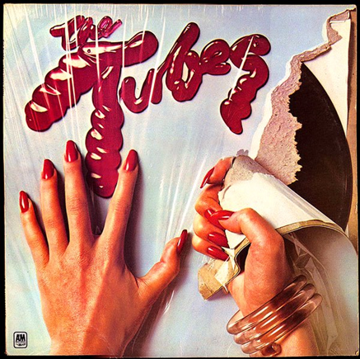
HOLMFIRTH PICTUREDROME
FRIDAY 21 OCTOBER
TICKETS: £27.50 (INC. BOOKING FEE)
BOOK ONLINE: PICTUREDROME BOX OFFICE
VENUE EMAIL: info@picturedrome.net
VENUE: FACEBOOK / STAGE TIME: 8PM
MARKET STREET, HOLMFIRTH, WEST YORKSHIRE, HD9 7DA
www.picturedrome.net
GLASGOW, THE ART SCHOOL
SATURDAY 22 OCTOBER
TICKETS: £26.40 (INC. BOOKING FEE)
BOOK ONLINE: SYNERGY CONCERTS / DOORS: 19:30
VENUE: FACEBOOK, TWITTER
GSA STUDENTS’ ASSOCIATION, 20 SCOTT STREET, GLASGOW, G3 6PE
www.theartschool.co.uk

THE TUBES - BIOGRAPHY
The Tubes were arch satirists of popular culture whose outrageous performance art concepts — which swung wildly from soft-core pornography to suit-and-tie conservatism — frequently eclipsed their elusive musical identity. The beginnings of the group originated in Phoenix, Arizona in the late ’60s, where guitarist Roger Steen, drummer Prairie Prince, and a bassist had a band called the Red White and Blues Band
After moving to San Francisco in 1969, in 1972 they united with another Phoenix band, the Beans, (alternately billing themselves as the Radar Men from Uranus) and eventually changed their name to The Tubes with the addition of Michael Cotten (keyboards) and former roadie Fee Waybill (lead vocals).
The Tubes attracted a cult following on the strength of their parodic songs and the group’s surreal live shows, which featured Waybill adopting a variety of stage personas including the crippled Nazi Dr Strangekiss, country singer Hugh Heifer, and Quay Lewd, a drug-addled British pop star. In the early 1970s they opened for Led Zeppelin and Iggy and the Stooges.
After signing to A&M Records in 1975, they released their critically acclaimed eponymous debut album The Tubes, followed a year later by the album Young and Rich. While both albums failed to translate the manic energy and theatrical power of their live shows onto record, the single White Punks on Dope became a minor hit and a radio staple, and went on to be covered by Motley Crue and Nina Hagen.
After 1977′s failed concept record The Tubes Now, the group toured England, where a series of banned performances made them a media sensation. However, during the recording of the concert LP What Do You Want From Live, Waybill broke his leg on-stage while acting out his punk character Johnny Bugger; the remainder of the tour was cancelled, and with it died the band’s chart momentum. After returning to America, they recruited producer Todd Rundgren and recorded 1979′s Remote Control, a concept album exploring the influence of television; when it met a similar commercial fate as its predecessors, The Tubes were dropped by A&M.
After signing to Capitol, they recorded 1981′s Completion Backwards Principle, with producer David Foster, an album based on an actual sales training instruction manual; both Talk To Ya Later and Don’t Want to Wait Anymore earned significant radio play, and the LP became band’s first Top 40 hit.
With its provocative video, the single She’s A Beauty reached the Top Ten, and pushed the 1983 album Outside/Inside, into the Top 20 Albums chart. After 1985′s Love Bomb stiffed, The Tubes split.
In 1993, The Tubes reunited; consisting of Waybill, Steen, Anderson, Prince, and new keyboardist David Medd. In 1996, they toured America and Europe before releasing a new LP, Genius of America. In 2000, The Tubes embarked on another extensive tour, issuing the live greatest hits album Tubes World Tour to commemorate the event. The band appeared at London’s Shepherd’s Bush Empire in December 2004, and the show was documented on the CD Wild in London, released the following year.

THE TUBES – OFFICIAL WEBSITE / THE TUBES – OFFICIAL FACEBOOK
THE TUBES – OFFICIAL TWITTER

# # #

For interview opportunities, review tickets & photo passes, please contact
Peter Noble and Dom Athanassiou at Noble PR Consultancy
Tel. 0207 272 7772, peter@noblepr.co.uk, dom@noblepr.co.uk

